# Testing, QA and QC

## Testing

**# Source**: **Chatgpt (GPT-5-Standard) at [8/12/2025]**

* **Meaning:** The **process of executing software** to find defects and verify it works as expected.
* **Focus:** Detect problems in the product.
* **Scope:** Narrow — part of the QA process.
* **Goal:** *Identify* bugs.
* **Who does it:** Testers / QA engineers.
* **Example:** Running a login test case to see if the user can log in successfully.

## QA – Quality Assurance

**# Source**: **Chatgpt (GPT-5-Standard) at [8/12/2025]**

* **Meaning:** A **process-oriented** approach that ensures the **methods, standards, and procedures** used during development will result in a quality product.
* **Goal:** *Prevent* defects.
* **Focus:** Improving and controlling **how** the product is built.
* **Timing:** Throughout the Software Development Life Cycle (SDLC).
* **Example:**
  + Defining coding standards.
  + Setting up review checklists.
  + Choosing a testing strategy before development starts.

💡 **Simple example:**

* **Requirements phase:** QA checks that requirements are clear, consistent, and testable.
* **Design phase:** QA ensures design follows best practices and standards.
* **Development phase:** QA confirms coding standards, reviews, and processes are followed.
* **Testing and release:** QA verifies that testing procedures meet quality criteria.

### Key Difference Table

**# Source**: **Chatgpt (GPT-5-Standard) at [8/12/2025]**

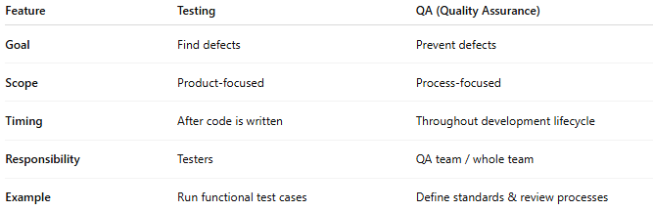

|  |  |  |
| --- | --- | --- |
| **Feature** | **Testing** | **QA (Quality Assurance)** |
| **Goal** | Find defects | Prevent defects |
| **Scope** | Product-focused | Process-focused |
| **Timing** | After code is written | Throughout development lifecycle |
| **Responsibility** | Testers | QA team / whole team |
| **Example** | Run functional test cases | Define standards & review processes |

💡 **In short:**

* **Testing** = Checking the product.
* **QA** = Ensuring the process makes a good product.

## QC – Quality Control

**# Source**: **Chatgpt (GPT-5-Standard) at [8/12/2025]**

* **Meaning:** A **product-oriented** approach that **checks the actual product** to ensure it meets requirements and is free of defects.
* **Goal:** *Detect* defects.
* **Focus:** Inspecting and testing the **finished product**.
* **Timing:** After the product (or part of it) is built.
* **Example:**
  + Running functional tests.
  + Performing UI checks.
  + Measuring performance.

### Key Difference Table

**# Source**: **Chatgpt (GPT-5-Standard) at [8/12/2025]**

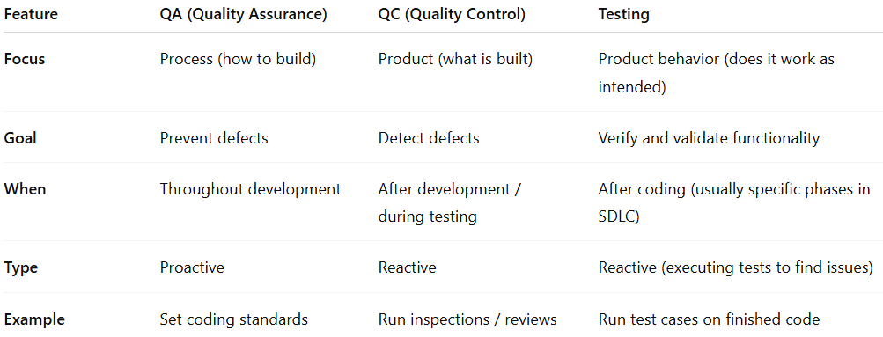

| **Feature** | **QA (Quality Assurance)** | **QC (Quality Control)** | **Testing** |
| --- | --- | --- | --- |
| **Focus** | Process (how to build) | Product (what is built) | Product behavior (does it work as intended) |
| **Goal** | Prevent defects | Detect defects | Verify and validate functionality |
| **When** | Throughout development | After development / during testing | After coding (usually specific phases in SDLC) |
| **Type** | Proactive | Reactive | Reactive (executing tests to find issues) |
| **Example** | Set coding standards | Run inspections / reviews | Run test cases on finished code |

💡 **In short:**

* **QA** = Make sure the **recipe** for making the cake is correct and followed.
* **QC** = Taste and inspect the **cake** to see if it’s good.

## Relation of testing for QA and QC

**# Source**: **Chatgpt (GPT-5-Standard) at [8/12/2025]**

Alright — here’s how **testing** connects to **QA** and **QC**:

### 1. QA (Quality Assurance) & Testing

**# Source**: **Chatgpt (GPT-5-Standard) at [8/12/2025]**

* **Relation:** Testing is **one of the activities inside QA**, but QA is much bigger.
* QA sets the **processes, standards, and plans** for testing.
* Without QA → testing may be unorganized or miss important areas.
* **Example:**
  + QA defines that “all features must have automated regression tests.”
  + Testing team follows that rule and runs the tests.

### 2. QC (Quality Control) & Testing

**# Source**: **Chatgpt (GPT-5-Standard) at [8/12/2025]**

* **Relation:** Testing is **a main tool used in QC** to check the product for defects.
* QC focuses directly on the **product quality**, and testing is how we inspect that.
* Without testing → QC has no way to confirm if the product works correctly.
* **Example:**
  + QC checks the login feature by executing test cases.
  + If a bug is found, it’s reported for fixing.

### Putting It Together Visually

**# Source**: **Chatgpt (GPT-5-Standard) at [8/12/2025]**

* **QA** → Big umbrella covering all quality processes (includes planning testing).
* **QC** → Hands-on product checking (mainly done through testing).
* **Testing** → The actual execution of checks, part of both QA and QC, but for different purposes:  
  + In **QA**, it’s to confirm the process works.
  + In **QC**, it’s to confirm the product works.

💡 Simple analogy:

* **QA** = Planning how to make a safe car.
* **QC** = Inspecting the finished car.
* **Testing** = Driving the car to see if it runs well.